Copilot-assisted PowerPoint Deck Generation
Capabilities, architecture, quality pipeline, and multi-agent design patterns

Purpose: This document explains how an AI assistant can generate high-quality PowerPoint decks by combining LLM reasoning, grounding, specialized agents, design logic, and document rendering.

Prepared for: Danish Khan | Date: 01 July 2026

1. Executive Summary
Copilot-style PowerPoint generation should be understood as a structured AI workflow, not as a single prompt directly converted into slides. The system first understands the user intent, grounds the request with available context, plans the storyline, generates slide content, applies design and visual logic, runs quality checks, and finally renders a PowerPoint deck.
- The quality comes from planning before writing, not just text generation.
- Grounding improves relevance by connecting the prompt with files, Microsoft 365 context, and permitted enterprise data.
- Multi-agent design improves quality by assigning specialist responsibilities such as content writing, summarization, tone refinement, visual selection, and QA review.
- The final rendering layer converts the structured slide plan into a professional .pptx file with layouts, formatting, visuals, and speaker notes.
Simple mental model: Copilot PPT generation = LLM Brain + Context Grounding + Agent Team + Design Engine + Rendering Engine.

2. What Copilot can do for PowerPoint deck generation
For a PowerPoint request, Copilot can help transform a raw prompt, meeting notes, Word document, Excel data, or business narrative into a structured presentation. Typical capabilities include:
- Create a complete slide outline with title slide, agenda, body sections, roadmap, risks, and conclusion.
- Convert long text into slide-friendly bullets and executive summaries.
- Generate or suggest speaker notes for each slide.
- Suggest diagrams, charts, icons, and visual metaphors based on slide purpose.
- Adapt the tone for leadership, business stakeholders, engineers, governance teams, or product teams.
- Use provided files and permitted enterprise context to make the deck more relevant and evidence-based.
Figure 1. Reference architecture for Copilot-assisted PPT generation
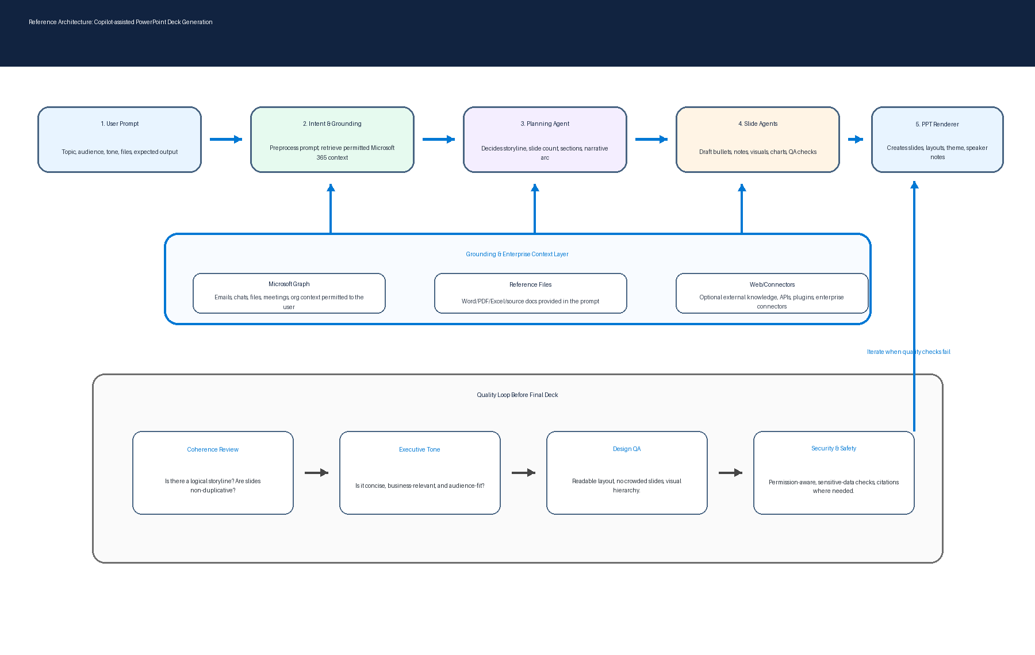

3. End-to-end architecture explained

3.1 User Prompt Layer
The process starts when the user describes the desired deck. A good prompt normally includes the topic, audience, tone, purpose, preferred slide count, source files, and any constraints such as branding or confidentiality.

3.2 Intent Understanding Layer
The LLM interprets what the user wants. It identifies whether the request is for an executive deck, technical architecture, performance review, roadmap, business case, or training material.

3.3 Grounding Layer
Grounding enriches the prompt with relevant context from uploaded files, permitted Microsoft 365 data, references, and optional web or connector sources. Microsoft describes grounding as improving prompt specificity and making answers more relevant to the task; Microsoft 365 Copilot also scopes data access to the signed-in user permissions.

3.4 Content Planning Agent
This agent behaves like a deck architect. It decides the narrative flow, section breaks, slide count, key messages, and what each slide should achieve.

3.5 Slide Generation Agents
Specialized agents create slide-level content. One agent may write bullets, another may summarize context, another may adjust tone, another may suggest visuals, and another may check for consistency.

3.6 Design and Visual Layer
The design layer chooses layout patterns such as title-and-content, two-column comparison, timeline, process diagram, heatmap, dashboard summary, or executive takeaway slide.

3.7 Rendering Engine
The final structured plan is converted into a PowerPoint file. This stage creates slides, text boxes, shapes, images, charts, speaker notes, and applies theme-level formatting.

3.8 Quality and Governance Layer
Before delivery, the output should be reviewed for clarity, duplication, visual density, factual grounding, privacy, and permission-aware data usage.

4. Multi-agent architecture
A multi-agent architecture divides a complex task into smaller responsibilities. Instead of one model trying to plan, write, design, fact-check, and render everything at once, an orchestrator coordinates multiple specialist agents.
Agent | Responsibility | Example output
Orchestrator | Routes the request, manages dependencies, merges results, and triggers quality loops. | “Generate a 10-slide executive deck using supplied notes.”
Content Agent | Writes slide titles, key messages, and draft bullets. | Slide 3: key business challenges and impact.
Summarization Agent | Compresses long documents or meeting notes into concise points. | Three executive takeaways from a 10-page document.
Tone Agent | Adjusts language for leadership, technical, or business audiences. | Transforms technical detail into board-level wording.
Visual Agent | Recommends diagrams, icons, charts, and layouts. | Architecture diagram, timeline, risk matrix.
Data Agent | Uses files or data tables to extract evidence and metrics. | Cost trend chart or KPI summary.
Reviewer Agent | Checks coherence, duplication, readability, and missing context. | Identify slides that are too dense or off-message.

Figure 2. Multi-agent patterns used to improve deck quality
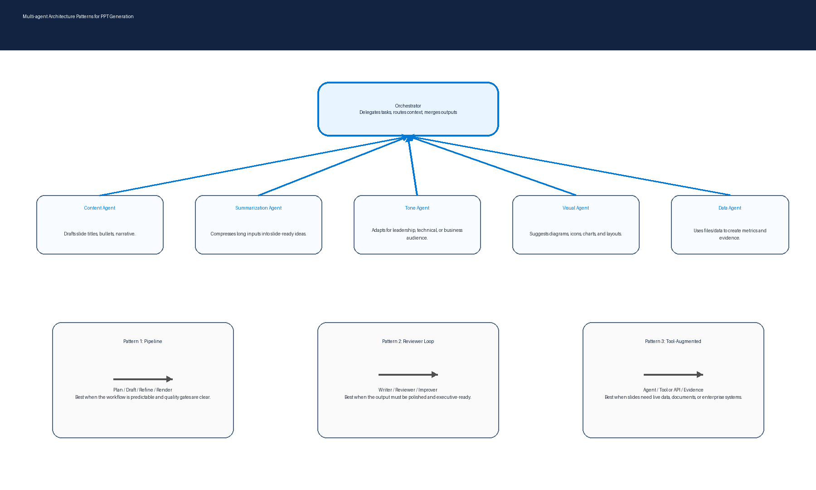

5. Common multi-agent patterns

Pipeline pattern
Sequential flow: planning agent, writing agent, design agent, reviewer agent, and rendering layer. Best for predictable deck creation.

Reviewer loop pattern
A writer generates content, a reviewer critiques it, and an improver revises it. Best for polished executive communication.

Orchestrator pattern
A central orchestrator decides which agent or tool should run next. Best for complex requests where some slides need data, some need visuals, and some need summary.

Tool-augmented pattern
Agents call tools such as Microsoft Graph, enterprise search, Excel parsers, APIs, or chart generators. Best when the deck must be grounded in evidence or live enterprise systems.

Hierarchical / child-agent pattern
A parent agent delegates specialized tasks to child agents, such as a finance agent, data governance agent, or visual design agent. Best for modular enterprise workflows.

6. Why this architecture gives better quality results
- It separates planning from writing, reducing random slide flow.
- It grounds the content in supplied and permitted context, reducing generic output.
- It uses specialized agents so each part of the deck has a clear owner.
- It supports review loops, so the first draft can be improved before final rendering.
- It applies design logic, so the deck is visually structured rather than just text-heavy.
- It allows governance checks for permissions, sensitive data, and factual consistency.

7. Example architecture mapped to your data-engineering world
Copilot PPT component | Equivalent in data/AI engineering architecture
Orchestrator | Airflow, Databricks Workflows, Azure Durable Functions, Semantic Kernel planner
Specialized agents | Microservices, ML pipelines, Spark jobs, task-specific LLM chains
Grounding layer | Data lake, Microsoft Graph, SharePoint, vector database, enterprise search
Tool calls | REST APIs, Graph API, Databricks SQL, Power BI/Fabric APIs
Quality gate | Unit tests, data quality checks, model evaluation, human review
PPT rendering | PowerPoint API, python-pptx, Office add-in, or document generation service

8. Recommended blueprint if you want to build a similar PPT-generation system
- Frontend: chat UI or Teams app where the user provides the prompt and uploads source files.
- Orchestration: Semantic Kernel, LangGraph/LangChain, Azure AI Foundry, or custom workflow service.
- LLM layer: Azure OpenAI / approved enterprise LLM endpoint.
- Retrieval layer: Microsoft Graph, SharePoint, OneDrive, Databricks, vector search, document parser.
- Agents: planner, content writer, summarizer, data analyst, visual designer, reviewer, renderer.
- Rendering: PowerPoint template engine, python-pptx, Office APIs, or Microsoft Graph APIs.
- Governance: identity-based access, logging, citations, human approval, prompt/response audit, sensitive data scanning.
- Evaluation: deck rubric covering storyline, slide density, factuality, visual quality, and executive readiness.

9. Practical prompt template for better PPT output
Prompt template: Create a [number]-slide PowerPoint deck on [topic] for [audience]. Use a [tone] tone. Include: problem statement, current state, architecture, benefits, risks, roadmap, and conclusion. Use the attached files as source context. Make slides executive-friendly, concise, and include speaker notes.

10. References
- Microsoft Learn: How does Microsoft 365 Copilot work?: https://learn.microsoft.com/en-us/microsoft-365/copilot/microsoft-365-copilot-architecture
- Microsoft Learn: Agent architecture components: https://learn.microsoft.com/en-us/agents/architecture/components-of-agent-architecture
- Microsoft Learn: Copilot Studio solution architecture: https://learn.microsoft.com/en-us/microsoft-copilot-studio/guidance/architecture-overview

